**Ideation Phase**

**Define the Problem Statements**

|  |  |
| --- | --- |
| Date | 16 June 2025 |
| Team ID | LTVIP2025TMID44795 |
| Project Name | GrainPalette - A Deep Learning Odyssey In Rice Type Classification Through Transfer Learning |
| Maximum Marks | 2 Marks |

**Customer Problem Statement Template:**

Create a problem statement to understand your customer's point of view. The Customer Problem Statement template helps you focus on what matters to create experiences people will love.

A well-articulated customer problem statement allows you and your team to find the ideal solution for the challenges your customers face. Throughout the process, you’ll also be able to empathize with your customers, which helps you better understand how they perceive your product or service.

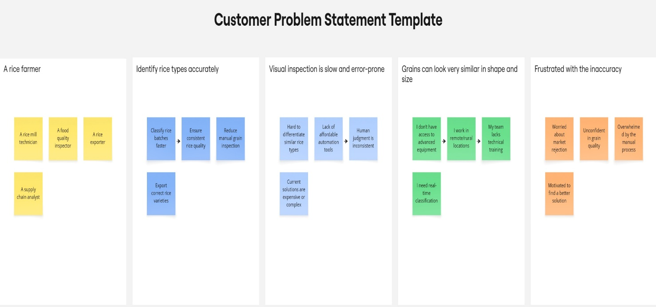

Reference: <https://miro.com/templates/customer-problem-statement/>

|  |  |  |  |  |  |
| --- | --- | --- | --- | --- | --- |
| **Problem Statement (PS)** | **I am (Customer)** | **I’m trying to** | **But** | **Because** | **Which makes me feel** |
| PS-1 | A rice farmer | Identify rice types in my harvest accurately | I rely on manual inspection | Its hard to tell types apart visually | Unsure, frustrated, and worried about selling low-quality rice |
| PS-2 | A rice mill technician | Quickly classify rice batches during processing | I don’t have time for detailed checking | Manual methods are slow and error-prone | Pressured,inefficient,and stressed |